
Cancer Research and Innovation
Newsletter | Summer 2026 (Issue 2)
At a glance
Key dates  • Successful 2026/27 Research and Innovation Awards confirmed in August  • Innovate UK Funding Webinar 3rd September | Highlights  • Alliance R&I awards - funded projects announced  • Axana MDT to be deployed at HHP  • Celebrating success of colleagues across HNY  • NIHR Bootcamp Success  • Innovate UK Funding

Research and Innovation Awards 2026/27: project spotlights
The Humber and North Yorkshire Cancer Alliance Research and Innovation Awards 2026/27 have supported a strong portfolio of projects designed to improve cancer pathways, patient experience and future evidence generation.
In this edition we highlight three successful projects from the awarded portfolio: Peachy proof of principle, a non-invasive breath and urine diagnostic assay for NRF2-overactive cancers, and SACT ePROMs. These projects demonstrate the breadth of innovation across treatment side-effect management, earlier and less invasive diagnostics, and digital patient-reported outcome measures.
Peachy proof of principle – Regional Centre
Peachy proof of principle will test the acceptability and practical feasibility of using photobiomodulation for extra-oral mucositis in children and young people undergoing cancer treatment or stem cell transplantation.
The project responds to an important supportive care need. Children and young people receiving cancer treatment can experience severe mucositis beyond the mouth, and photobiomodulation is already evidenced for reducing oral mucositis. This project explores an under-researched extra-oral area where there may be unmet need.
The work is expected to generate feasibility and acceptability evidence, inform a larger future funding application, and support wider adoption if the approach reduces severe mucositis and related complications.
A non-invasive diagnostic assay to detect NRF2-overactive cancers from breath and urine - University of York
This project is about developing a non-invasive diagnostic assay using breath and urine to detect NRF2-overactive cancers and support targeted identification of eligible patients.
Overactive NRF2 is associated with aggressive, therapy-resistant cancers, while current gene-expression profiling is not practical for broad NHS adoption. The proposed approach focuses on laboratory and analytical assay development using breath and urine biomarkers, supported by computational classification and validation against cancer-relevant samples.
The project is expected to generate assay evidence for future clinical translation, support targeted therapy selection and provide a platform for larger funding applications. It aligns closely with earlier diagnosis, treatment personalisation, care closer to home and quality-of-life improvement by exploring less invasive testing.
SACT ePROMs – Humber Health Partnership
The SACT ePROMs project will procure or configure electronic patient-reported outcome measure tools and pilot it with a defined oncology cohort.
Oncology follow-up and SACT reviews can rely on variable symptom reporting. ePROMs could help standardise reviews, focus clinical time where need is greatest, and improve digital cancer care. The project will include patient feedback in governance and evaluate workflow, usability and clinical impact.
Expected benefits include improved patient-clinician conversations, fewer unnecessary contacts, more standardised reviews and learning to inform a sustainable move to a cost-neutral platform where feasible.

Axana MDT to be deployed at Hull University Teaching Hospitals NHS Trust
Like many cancer services, HUTH continues to manage significant operational pressure, with a backlog of patients awaiting treatment due to constraints in surgical and radiotherapy capacity. By streamlining MDT preparation and coordination it can release valuable clinical time.
As part of a research study Axana MDT clinical application has been deployed at Hull University Teaching Hospitals NHS Trust (HUTH). Dr Kanwal Tariq, Consultant Respiratory Physician and Cancer Alliance Lung Clinical Lead said ‘I’ve already seen the benefits Axana MDT is bringing at an organisation where it has been live since last September, and I’m keen to achieve the same here.’
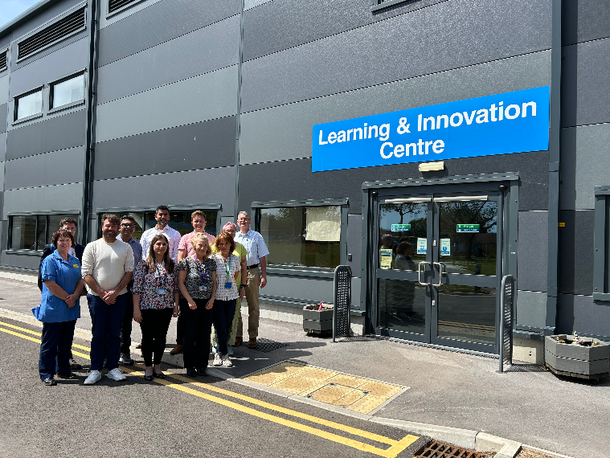
One of the country’s busiest lung cancer services
HUTH serves a catchment of 600,000 people across Hull and the East Riding and acts as the tertiary cancer treatment centre for a wider population of around 1.25 million. The scale of its lung cancer workload is considerable: in 2025, 2,827 cases were referred to the lung cancer MDT, with 1,887 discussed, and 569 new lung cancers diagnosed.
Axana visits the team at Hull for the project kick-off meeting
Hull has a high incidence of lung cancer, driven by high smoking rates - well above the national average. This was one of the main reasons the area was selected as one of ten pilot sites for the national Lung Cancer Screening Programme. Now well established after more than four years, and currently being rolled out to the East Riding, the programme has diagnosed around 400 cancers, 88% of them at an early stage. The Axana team has a long-standing relationship with HUTH, having supported the Trust’s lung cancer screening service to go live with Aidence’s radiology AI. HUTH was Aidence’s launch site for Veye Reporting, a structured radiology reporting solution that surfaces AI findings directly within the clinical report. It went on to become the leading solution for NHS lung cancer screening.
Innovate UK Funding Opportunity
The advancing innovation in accelerated cancer diagnosis competition, opens on 1 September, briefing webinar 3 September.
Innovate UK, on behalf of the Office for Life Sciences’ (OLS) Cancer Healthcare Goals programme, will invest up to £25.4 million in innovative CR&D projects. This funding will be to support the clinical validation and evaluation of early cancer diagnostic technologies and devices.
The aim of this competition is to accelerate the development of diagnostic innovations that enable the earlier detection and diagnosis of cancer, particularly less common cancers. Less common cancers are any cancer type outside of breast, prostate, lung and bowel cancer, plus rare forms of these four cancer types.
Your project must focus on developing, validating or evaluating diagnostic technologies or approaches that demonstrate clear potential for clinical and health economic impact. Projects can generate robust evidence to support regulatory approval and future NHS adoption. To register for the webinar see link Advancing innovation in accelerated cancer diagnosis - Applicant briefing - Innovate UK Business Connect

York and Scarborough Celebrate Double Win
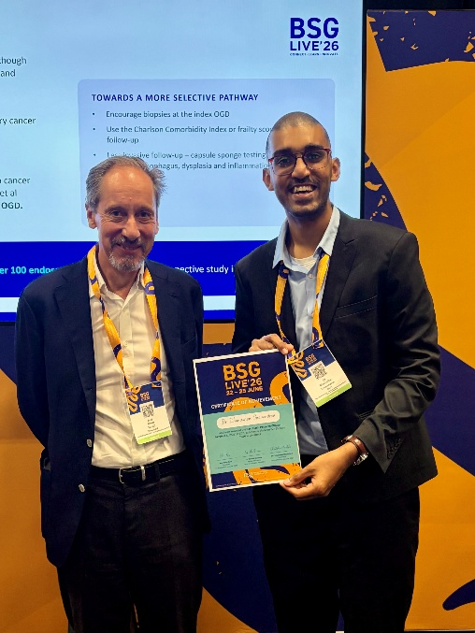
Congratulations to Dr Dhanushan Gnanendran, Gastroenterologist and Clinical Fellow, York and Scarborough Teaching Hospitals NHS Trust, who was recognsied at the British Society of Gastroenterology Annual Conference for Best Flash Poster Presentation.
Dr Gnanendran also went on to win the Process and Systems Innovations category at the Medipex Innovation Awards for the same project to improve bowel preparation ahead of colonoscopy procedures.

Professor James Turville and Dr Dhanushan Gnanendran at the BSG Conference
During his foundation training at York Hospital, Dhanushan identified a common challenge: many patients attending for colonoscopy were not adequately prepared, leading to repeat procedures, delays in diagnosis and, in some cases, hospital admission.
Supported by funding from the Humber and North Yorkshire Cancer Alliance as part of last year’s Research and Innovation Awards, Dhanushan introduced a simple risk-scoring tool to identify patients who would benefit from additional support before their procedure. Following implementation, the proportion of patients with inadequate bowel preparation fell dramatically, improving patient experience while increasing endoscopy capacity and reducing avoidable admissions.
Reflecting on the project, Dhanushan said:
"The results have been hugely encouraging for both patients and clinicians. I hope this approach can be adopted more widely to improve efficiency and patient care across endoscopy services nationally."
The project highlights how frontline innovation can deliver measurable improvements in care delivery while supporting the NHS to make best use of valuable clinical resources.
NIHR Team Science Bootcamp
Congratulations also go to Dr Jo Cairns and Ruth Joubert who were successful in their application to attend the NIHR Team Science Bootcamp. This year’s NIHR bootcamp is for researchers from any career stage with an interest in data-science driven health and social care research and the Team Science approach.
This is a 3-day fully funded camp where participants will be coached in the principles of NIHR team science and supported to develop interdisciplinary teams with the aim of applying for future funding.
Thanks to Professor John Greenman, Hull York Medical School and Chair of the HNY Cancer Research Collaborative for supporting the application.
Congratulations to Dr Farzana Haque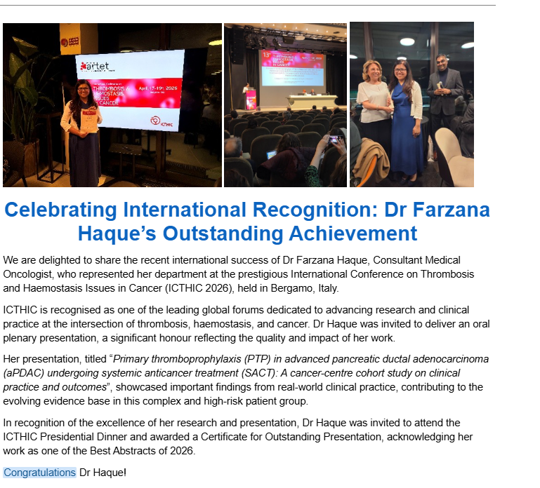Get in touch
If you have cancer research or innovation news to share and would like it included in the newsletter, please contact hnyicb-ery.cdi.team@nhs.net

